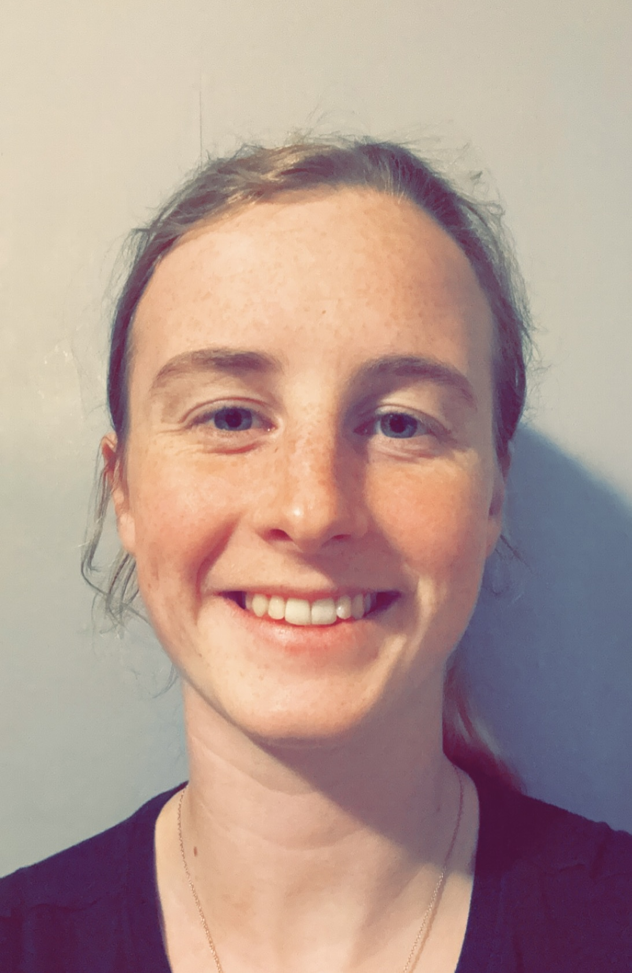 |  |  |  | Miss S Coghlan – 7SC

Experience
September 2023 - Present
Teacher of Science Ellowes Hall Sports College

Education
Harper Adams University
- BSc (Hons) Bio veterinary Science (2:1)

University of Worcester
- Post Graduate Certificate of Education (Secondary) in Biology

A bit about me
I have worked at Ellowes Hall for the past year on placement and have really enjoy being part of the Ellowes Hall family. I came into teaching after 5 years working alongside veterinary staff in a stud yard, taking care of their health, wellbeing and caring out DNA analysis.
I have a real passion for science and enjoy teaching it even more, sharing my passion with the students in my classes, my favorite science subject is Biology.
In my spare time I enjoy spending time with my horses, I take part in lots of show jumping competitions. I also enjoy weekends out on my motorcross bikes as well as spending time with family and friends as much as possible.
I believer in supporting students to stay safe, happy, healthy and to achieve their aspirations. My role as a form tutor is to support you as much as I can. I look forward to meeting you in September.

Ellowes Hall Sports College
DY3 2JH
 |  | 01384 686600
 |  | scoghlan@ellowes.dudley.sch.uk
 |  | www.ellowes.co.uk

